AGILE PLAYER

This document is the Agile Player application User manual.
Written for version 1.0.xx.xx. For later versions, this may not cover everything in the application, please go to Wiki Page Online for latest up-to-date application help information.
To download the latest version of Agile Player, please visit this link here.
This document is released under the Creative Commons Zero v1.0 Universal

CC0 1.0 Universal

CREATIVE COMMONS CORPORATION IS NOT A LAW FIRM AND DOES NOT PROVIDE
LEGAL SERVICES. DISTRIBUTION OF THIS DOCUMENT DOES NOT CREATE AN
ATTORNEY-CLIENT RELATIONSHIP. CREATIVE COMMONS PROVIDES THIS
INFORMATION ON AN "AS-IS" BASIS. CREATIVE COMMONS MAKES NO WARRANTIES
REGARDING THE USE OF THIS DOCUMENT OR THE INFORMATION OR WORKS
PROVIDED HEREUNDER, AND DISCLAIMS LIABILITY FOR DAMAGES RESULTING FROM
THE USE OF THIS DOCUMENT OR THE INFORMATION OR WORKS PROVIDED
HEREUNDER.

Table of Contents
Introduction 2
Features And Specification 3
Agile Player Core Features 3
NOTES: 3
System Requirements And Installation 4
User Interface (GUI) 5
Settings File (i.e. Switching Renderer, Modify Performance Settings) 8
Troubles Shooting (FAQ) 10
Agile Player doesn't work: 10
Performance problems, errors in sound and/or synchronization 10
How to switch renderer 10

Introduction
Agile Player is An Audio player with downsampler, upsampler and bit-converter written in C#.
The main goal of Agile Player is to be as accurate as possible with audio playback and brings the best listening experience possible.
What the point of having another audio player while there are plenty out there .... well, the answer is that Agile Player render audio in new unique way, making sure that:
- Accurate play timing, a specific sample is played at the time where it supposed to
- When it is neccessary , do downsampling/upsampling and/or bits-converting accurately during play time.
- Very simple GUI, just open audio files/folders and ready to go.
Agile Player is based on My Nes emulator (see https://github.com/alaahadid/My-Nes), the idea is to build an audio player based on emulation way. i.e. it does like an emulator which emulates a machine, Agile Player load audio file, then clock like real machine: process samples on clocks based way, intervals in time, not just simply copy-paste buffers into a renderer.
This will deliver accuracy with timing, a specific sample plays at the time when it supposed to.
Agile Player does not use any kind of media codec, it uses built in audio processing.
Agile Player plays files with READ-ONLY, it does not effect nor make and change in the source file. In order to save playback settings, Record feature needs to be used.

Features And Specification
- Very simple GUI, just open audio files/folders and ready to go.
- Can save/load lists files
- Full audio controls (play, pause, stop...etc)
- db Meter display db level correctly (work with 16 bits only).

Agile Player Core Features
- Multithread player, the play-engine clocks on thread other than the gui (main thread).
- Support multi-renderer can be switched in settings (settings file in Documents). Currently supported renderers: SDL2 Audio (id=sdl2.audio) and SlimDX DirectSound (id=slimdx.directsound).
- Accurate play timing, a specific sample is played at the time where it supposed to.
- Automatic upsampling and downsampling. Can play in any desired frequency regardless of the source audio frequency, the engine take care of downsampling/upsampling if it is needed.
- Automatic bit per sample converting, can switch desired bit-per-sample regardless of the source audio bit-per-sample, the engine take care of converting bit-per-sampling if needed. All using correct equations.
- DB Fix feature, enables a simple fix for songs/tracks 0 samples by replacing each sample with input 0 with the input of 1 bit which is 1. It will be 0 db instead of infinity db. This is correct.
- Wave Shift feature, shift audio wave to make sure all samples above 0. Enabling this with DB Fix will make sure that the song/track is 100% correct sb measurements (no infinity db).
- Ability to record wav, save wav file of current played media with target settings (Channels, Frequency, Bits Per Sample, DB Fix and Wave Shift).
- Currently supported media formats (playback):
- Loseless WAV PCM, (8 bit, 16 bit, 24 bit and 32 bit).
- MP3 (16 bits only, still issues with it but works).

NOTES:
- Agile Player records to wave file with these settings: Channels Number, Frequency, Bits Per Sample, DB Fix and Wave Shift.
- When record, the application stops and freeze, it can take minutes before it done the recording, it may take a long time, that depends on the input size, also on target settings. After the records finishes, the application will open the folder where the recorded file is saved.

System Requirements And Installation
Usually Agile Player comes in portable package, which can be installed simply by extracting the content of that package anywhere in your machine. Note that Agile Player save settings and user files at the documents. In order to run Agile Player correctly in your machine, please make sure that your machine meets up these requirements:
- Agile Player can run at any version of windows that can run .net framework 4.8, such as Windows 7, 8, 8.1, 10 and 11.
- .Net Framework version 4.8 is required.
- Latest DirectX package from Microsoft.
- CPU: 2400 MHz or faster, multicore cpu is recommended for better performance. Agile Player is built for x86 cpus, but it should run without problems with x64 cpus (tested and runs perfectly)
- RAM: Agile Player usually uses about 30 to 60 MB ram. When huge list is loaded, it may use up to 200 MB. In other words, since Windows is running perfectly in your machine, you should not worry about ram at all when using Agile Player.

User Interface (GUI)
When open Agile Player, it will open the main window which look like this:
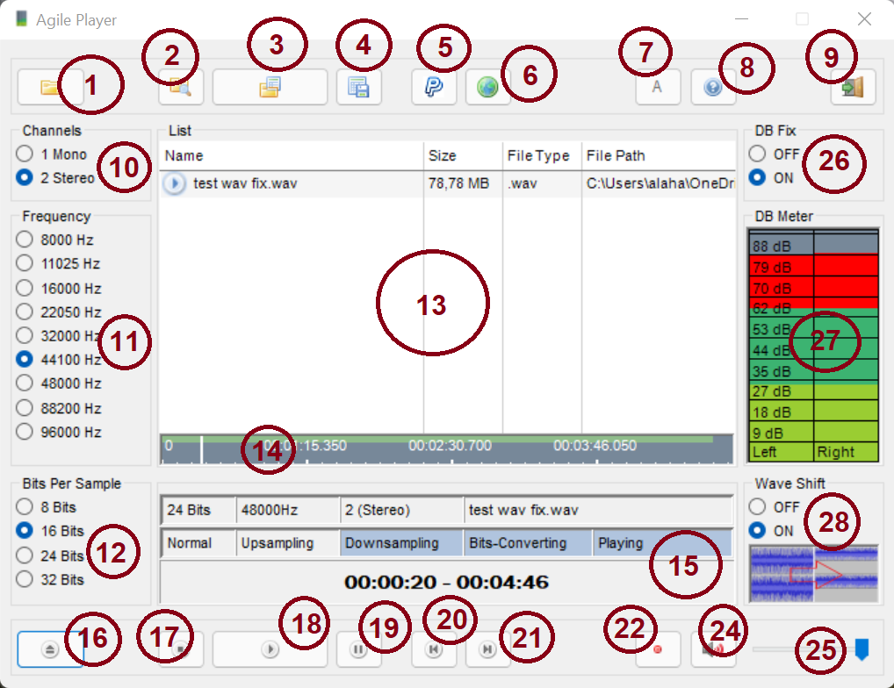
Open folder and scan for supported media formats, add files into the list if there is any found.
- Open folder and scan for supported media formats, including all folders inside selected, add files into the list if there is any found.
- Open playlist file, add files into the list if successfully opened and there is file in it.
Note: These three buttons will clear current list first.
- Save current list into list file.
- This button will open link into paypal to donate to the developer.
- Open current Agile Player repository online.
- Open Agile Player about window, displays current version and copyright information.
- Open Agile Player wiki page online.
- Exit Agile Player.
- Change playback target channels settings.
- Change playback target frequency settings.
- Change playback target Bits Per Sample settings.
- Play list, double click on a file in the list to play. Use buttons 1, 2, 3 and 16 to add files into the list. Use button 4 to save current list into a file. Use buttons 20 and 21 to cycle current file in the list.
- Time bar, display current play time, can be used to scroll in current playback time by simply clicking on it.
- Display current file in playback information: First line display current file bits-per-sample - frequency - channels - file name. Second line displays current playback situation by highlighting a text:
Normal when it is highlighted means the playback is playing current media without any processing.
Upsampling when it is highlighted means the current playback is doing upsampling, simply because of the target frequency is larger than the file frequency (displayed at the first line).
Downsampling when it is highlighted means the current playback is doing dowsampling, simply because of the target frequency is smaller than the file frequency (displayed at the first line).
Bits-Converting when it is highlighted means the current playback bits per sample does not match the file bits per sample (displayed at the first line).
Playing when it is highlighted means it is playing now. Not highlighted means either stopped or paused.
Third line display current play time - file duration.
- Open file(s) with supported media formats, add files into the list if there is any opened.
Note: This will clear current list first if open success.
- Stop playback.
- Play if playback is stopped or paused.
- Pause playback.
- Select Previous file in the list and play it.
- Select Next file in the list and play it.
- Record (or save) current file with target settings (10, 11, 12, 26 and 28 settings).
When record, the application stops and freeze, it can take minutes before it done the recording, it may take a long time, that depends on the input size, also on target settings. After the records finishes, the application will open the folder where the recorded file is saved.
Note: Agile Player plays files with READ-ONLY, it does not effect the source file. In order to save settings, button 22 needs to be used.
- Toggle mute.
- Volume control.
- DB Fix: When it is ON, it enables a simple fix for current playback, it replaces each sample played that the input of it is 0 with the input of 1 bit, which is 1. That will make samples 0 produce 0 db instead of infinity db. This is correct in physics. Enabling this will make the song feel more alive and comfortable. It is disabled by default. For more, please see https://github.com/alaahadid/Docs/blob/main/Audio%20And%20DB.txt.
- Display current db level of latest sample played (playback, not source file) at an interval. Works only with 16 bits.
- Wave Shift feature, shift audio wave to make sure all samples above 0. Enabling this with DB Fix will make sure that the song/track playback is 100% correct in physics since there will be no infinity db. It is disabled by default.

Settings File (i.e. Switching Renderer, Modify Performance Settings)
To locate settings file, please go to documents folder C:\Users\<user>\OneDrive\Documents\AgilePlayer, <user> is the user name.
Open file coresettings.ini (or make new file with that name if it does not exist)
- Renderer ID, line Audio_RendererID=: this is the current render id to use.
Set to Audio_RendererID=slimdx.directsound for SlimDX DirectSound renderer.
Set to Audio_RendererID=sdl2.audio for SDL2 Audio renderer.
Only these 2 renderers are supported in the current version of Agile Player . SlimDX DirectSound renderer is stable.
- Target Frequency, line Audio_TargetFrequency=: Target playback frequency playback settings. Can be set to any desired frequency, if there is an issue with large frequencies maybe changing buffer size might help. Example: Audio_TargetFrequency=44100.
- Target Channels, line Audio_TargetAudioChannels=: Target channels playback settings. Currently supported is : Audio_TargetAudioChannels=1 for Mono, Audio_TargetAudioChannels=2 for stereo.
- Target bits per sample, line Audio_TargetBitsPerSample=: Target Bits Per Sample playback settings. Currently supported is : Audio_TargetBitsPerSample=8 for 8 Bits, Audio_TargetBitsPerSample=16 for 16 bits, Audio_TargetBitsPerSample=24 for 24 bits and Audio_TargetBitsPerSample=32 for 32 bits.
- Target Buffer Size in KB, line Audio_RenderBufferInKB=: This is the buffer size in KB for renderers, if there is issue with frequency settings (large frequency) changing this to larger value might help fix playback. Example: Audio_RenderBufferInKB=9 buffer size is 9 kb.
- Target Clocks Per Second, line CPS_TargetCPS=: Specify how many clocks the core should clock per second, like fps (frames per second). The core clocks in clocks-per-second to get samples from the source file and process them then send them into selected renderer. The smaller the cps value the less clocks the core it does, but it might not-safe in synchronization speaking. CPS_TargetCPS=44 is stable and good, 50 is good as well. 75 makes the core clock too much in a second and that is not necessary, but may be perform better in some machines. The playback speed and accuracy does not affected by this settings, nor audio processing. The only thing may be affected is performance and synchronization (between the core and renderer).
- DB Fix setting, line Audio_DB_Fix_Enabled=: Audio_DB_Fix_Enabled=0 means db fix is disabled, Audio_DB_Fix_Enabled=1 means db fix is enabled. For more please see Features And Specification.
- Wave Shift setting, line Audio_Wave_Fix_Mode=: Audio_Wave_Fix_Mode=0 means wave shift is disabled, Audio_Wave_Fix_Mode=1 wave shift is enabled with mode 1. There is no other mode implemented yet in current version.
- Volume level, line Audio_Volume=: Set volume level percentage to any desired value between 0 and 100. Example Audio_Volume=76 volume level is 76 %.

Troubles Shooting (FAQ)

Agile Player doesn't work:
Please make sure that these packages are installed in pc:
- .Net framework 4.8
- C++ Runtime (Try latest, if doensn't work, installing older version of this package may work.)
If the problem isn't solved, please try to install SlimDX latest runtime, one can be found here: https://code.google.com/archive/p/slimdx/downloads (SlimDX Runtime .NET 4.0 x86 (January 2012).msi).

Performance problems, errors in sound and/or synchronization
- Please go to documents folder C:\Users\<user>\OneDrive\Documents\AgilePlayer, <user> is the user name.
- Open file coresettings.ini (or make new file with that name if it does not exist)
- Find line Audio_RenderBufferInKB= (or add it) then set it to Audio_RenderBufferInKB=9. Find line CPS_TargetCPS= and set it to CPS_TargetCPS=44. If problem remains, set Audio_RenderBufferInKB=16 and CPS_TargetCPS=50. Increasing RenderBufferSize and trying different values might help if the problem remain.

How to switch renderer
- Please go to documents folder C:\Users\<user>\OneDrive\Documents\AgilePlayer, <user> is the user name.
- Open file coresettings.ini (or make new file with that name if it does not exist)
- Find line Audio_RendererID= (or add it) then
Set to Audio_RendererID=slimdx.directsound for SlimDX DirectSound renderer.
Set to Audio_RendererID=sdl2.audio for SDL2 Audio renderer.
SlimDX DirectSound renderer is stable.

